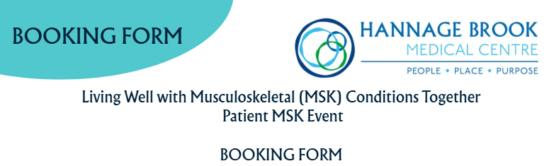

👤 Name:

🎂 DOB:

🏠 Address:

📞Telephone number:

📧 Email:

I will / won't (please delete) be attending the event on Wednesday 11th March 2026.

My preferred method of contact regarding this event is:

📱Text ☐ 📧 Email ☐ ✉️ Letter ☐

My weight is: ______________________

My height is: _______________________

♿ Please tell us if you have any special needs or requirements:

Please return your completed booking form and the Patient Passport form to:Hannage Brook Medical Centre, Hannage Way DE4 4JG

🌐Do visit our event webpage at LINK HERE for more information. Copies of the forms to
complete can be emailed to us at ddicb.hannagebrook@nhs.net

